Rover Simulator
User Manual
For rover software version 1.1, 17 October 2026.
Test your rover and your program on a computer before you test them on the floor.

Contents
1. What the simulator does
2. Starting the simulator
3. A tour of the screen
4. Running your program
5. Reading the map
6. The Log tab
7. The Rover tab: describing your rover
8. The Parameters tab
9. The Course tab: drawing your course
10. The Code tab
11. A good way to test
12. Troubleshooting

1. What the simulator does
The simulator runs your real program file on a computer, with a pretend rover on a pretend course. It is the same Python code you put on the hub: there is nothing to translate. Every Run reads the file again, so you can change your program, save it and run it again straight away.
Use it to:
- check your settings match your rover, before you spend time on the floor
- try your own route, or the autonomy, on your competition course
- see what the rover “thought” at every moment: every message, where it was, and what its sensors saw
- try design ideas, such as moving a sensor or adding wheels, without rebuilding anything

What it cannot tell you
The simulator is a model, so it is never perfect. Always test on the real rover too. In particular:
- The floor is perfectly flat and grippy, the battery never runs low and the motors never get tired.
- The sensors are simple models. The pretend colour sensor only knows the green and red patches you draw; everywhere else it reads white.
- For rovers with four or more wheels that cannot swivel, the way it turns is an estimate until you enter measurements from your real rover (chapter 7).
- The hub’s buttons are pressed for you: whenever a program waits for the RIGHT button, the simulator presses it. LEFT is never pressed.
- It runs desktop Python, not the hub’s MicroPython. A few things that work here can still fail on the hub.

2. Starting the simulator
You need Google Chrome or Microsoft Edge, and an internet connection the first time (the simulator downloads Python into the browser).

The simple way
- Double-click rover_sim.html in the simulator folder. It opens in your browser. Wait until the status at the top left of the map says READY.
- Click the Code tab, then Choose a file instead, and choose your program file (your .py file).
- Click Run.
From then on, every Run reads the latest saved version of your file. You do not need to choose it again until you reopen the page.

With Python installed
If your computer has Python, you can also start it with python sim/serve_sim.py from the folder that holds the sim folder. It opens the browser for you and reads spike_all_in_one.py from that folder, so save your program under that name (or choose a file as above).

3. A tour of the screen
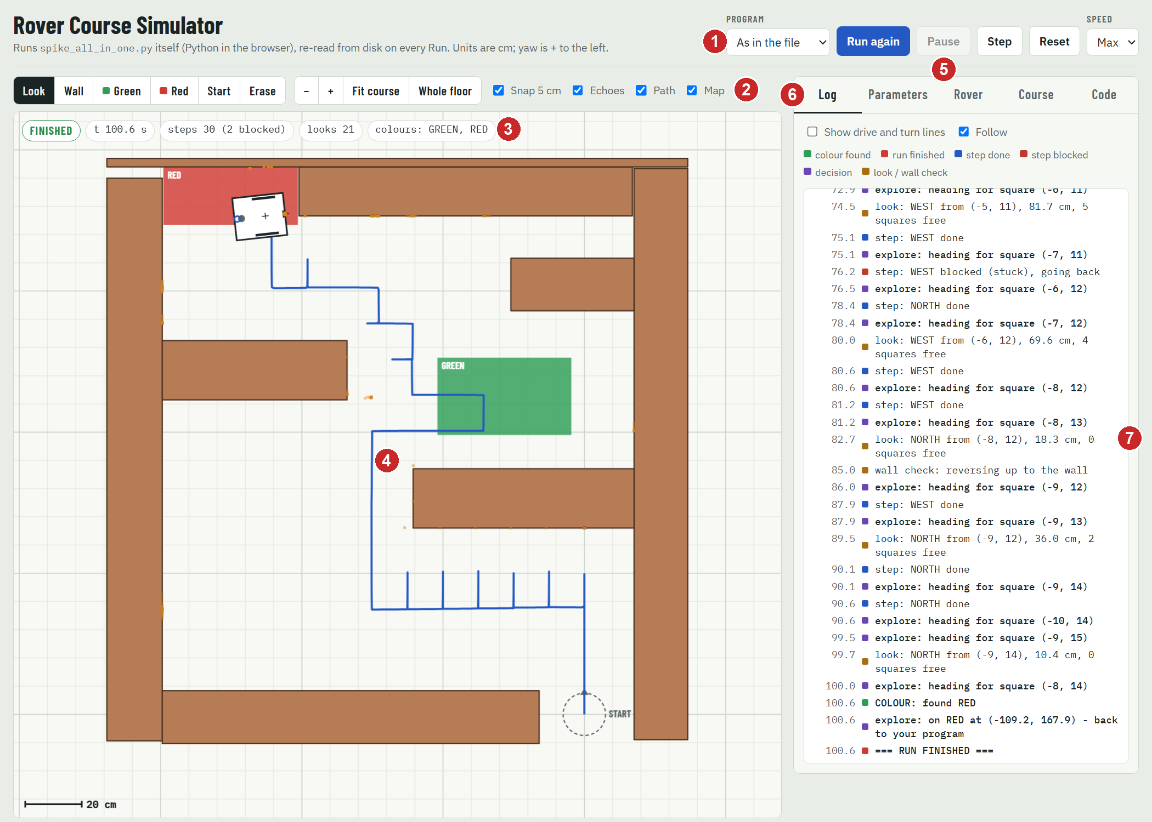
The simulator after a run. The numbers match the table below.
 | Part | What it is for
1 | Program | Which program to run. “As in the file” runs the one chosen at the bottom of your file.
2 | Tools and view | Draw the course, move and zoom the view, and choose what the map shows (chapters 5 and 9).
3 | Status bar | The run’s status, time, steps, looks and the colours found.
4 | Map | The course, the rover, and where it has been.
5 | Run controls | Run, Pause, Step, Reset and Speed (chapter 4).
6 | Tabs | Log, Parameters, Rover, Course and Code.
7 | Side panel | The open tab: here, the Log of everything the program printed.

4. Running your program
Program and run controls.
Control | What it does
Program | Which program to run. It lists every program in the runloop.run(...) lines at the bottom of your file, so you can switch without editing the file.
Run | Reads your file again and starts the run. While a run is going it says Restart; afterwards, Run again.
Pause / Resume | Freeze the run and carry on.
Step | Run until the program prints its next line, then pause. Press it again for the next line. Great for following a decision.
Reset | Stop the run and put the rover back at the start.
Speed | 1× is real time. Max runs as fast as the computer can.

Keyboard: R runs, Space pauses, N steps.

The status bar
Status | Meaning
READY | Python is loaded and waiting for you.
RUNNING / PAUSED | A run is going, or paused.
FINISHED | The program ended by itself.
ERROR | The program stopped with an error. The Log shows the message, in red, with the line number.
TIME LIMIT | The run went on for longer than the timeLimit parameter (900 s), so the simulator stopped it.

Next to it: the time in the run, the steps the autonomy made (and how many were blocked), the looks (distance measurements), and the colours found.
Watch out: A red Settings do not match the rover badge means a setting in your file does not match the rover on the Rover tab. Fix it before you trust a run: chapter 7 shows where.

5. Reading the map
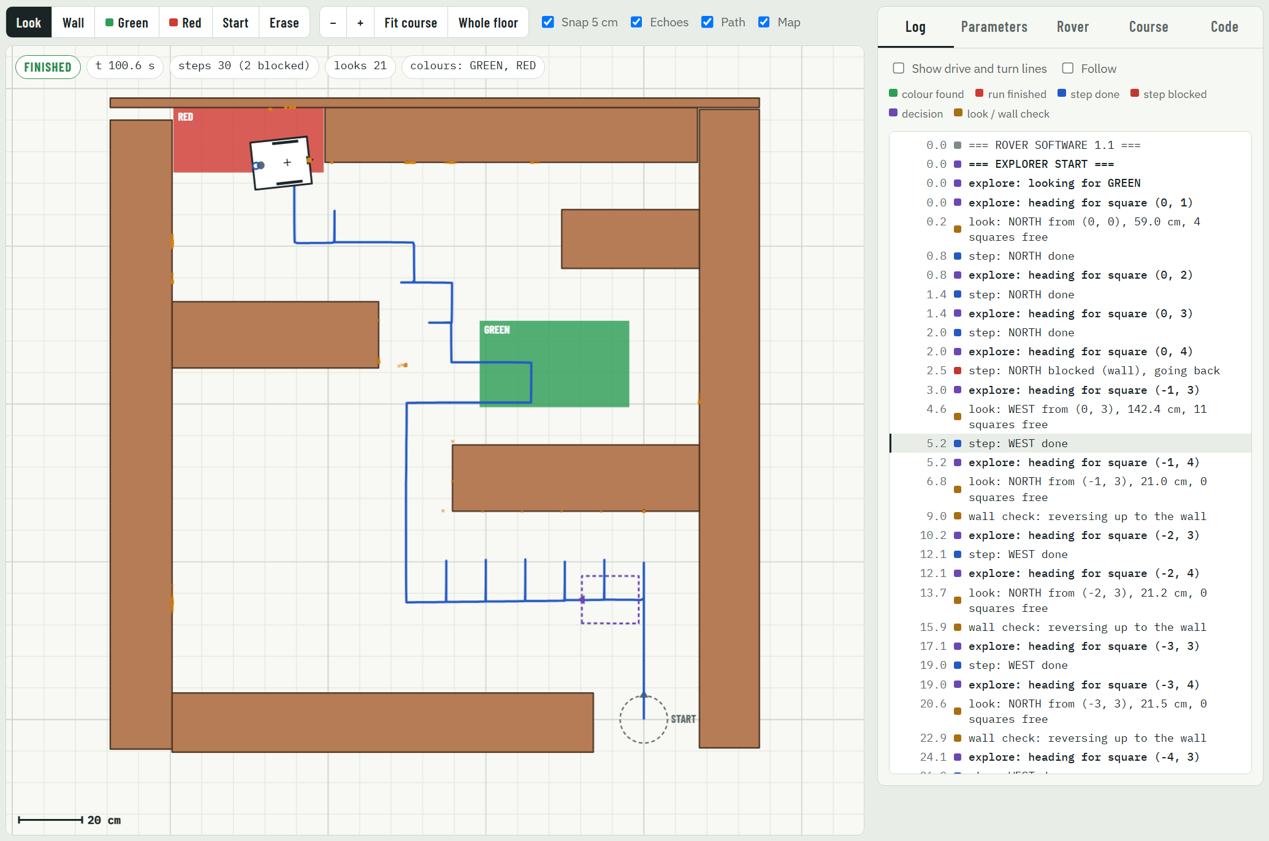
After a run. A log line is selected, so a dashed rover shows where the rover was when it printed that line.
On the map | What it shows
Brown boxes | Walls.
Green and red boxes | The colour patches.
Dashed circle and START | Where the rover starts. It always starts facing up the screen (NORTH).
The rover | Its outline, its wheels (dark = driven by a motor), the distance sensor (orange dot), the colour sensor (blue ring) and the turning point (+).
Blue line (Path) | Where the rover’s turning point went.
Orange dots (Echoes) | Where the distance sensor’s sound bounced back. An orange fan flashes each time it measures.
Shaded squares, crosses and bars (Map) | The explorer’s map (Maze explorer only): shaded = visited, red cross = too close to a wall to stand in, red bar = move blocked by a wall, red circle = the square it is heading for.
Dashed purple rover | Where the rover was when the selected Log line was printed.

Scroll to zoom in and out, towards the mouse pointer. With the Look tool, drag to move the view. Fit course zooms to the course; Whole floor shows the whole 10 m × 10 m floor. Untick Echoes, Path or Map to hide them.

6. The Log tab
The Log shows every line the program printed, with the time it was printed, in seconds. A coloured square shows what kind of line it is:
Colour | Kind of line
Green | A colour was found
Blue | A step was done
Red | A step was blocked, or the run finished
Purple | A decision (where the autonomy is heading next)
Orange | A look with the distance sensor, or a wall check
Grey | Any other message

- Click a line to see where the rover was when it printed it (a dashed rover on the map). Click it again to clear it.
- Show drive and turn lines also shows the detailed drive: and turn: lines. They are hidden at first, to keep the Log short.
- Follow keeps the newest line in view. It switches off when you click a line, so the Log stops jumping.
- Errors appear in red, with the line number in your file.

7. The Rover tab: describing your rover
Here you tell the simulator what your rover looks like. The simulator drives this rover, whatever your file says, so make it match the rover you built.
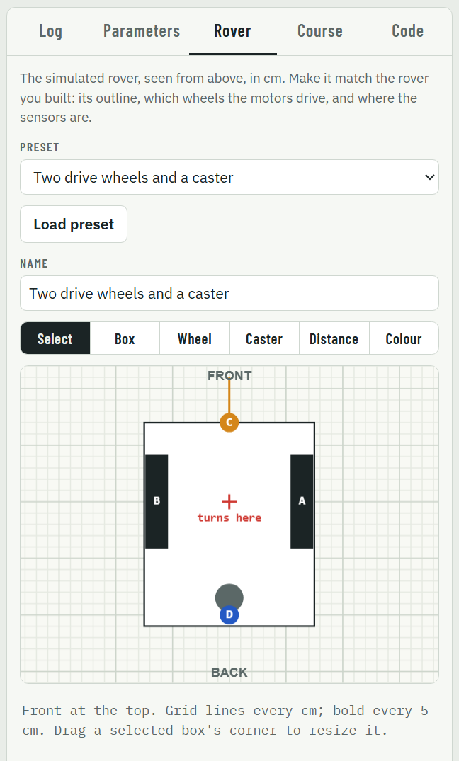
The top of the Rover tab: presets, name and the rover editor.

Starting from a preset
Choose the preset closest to your rover and click Load preset: two drive wheels and a caster; four or six wheels with two motors (skid steer); or rear drive with two free front wheels. Then give it your rover’s Name and change it to match.

The editor
The editor shows the rover from above, front at the top, with grid lines every centimetre (bold every 5 cm). Below it, the pointer’s position is shown in cm.
Tool | How to use it
Select | Click a part to change it. Drag it to move it. Drag a corner of a selected box to resize it. Press Delete to remove it.
Box | Drag to add a box to the body. Build the outline from boxes: one for the chassis, one for an arm sticking out, and so on.
Wheel | Click to add a wheel. It is driven by the motor already driving that side.
Caster | Click to add a caster or ball: a wheel that swivels.
Distance, Colour | Click to add a sensor.

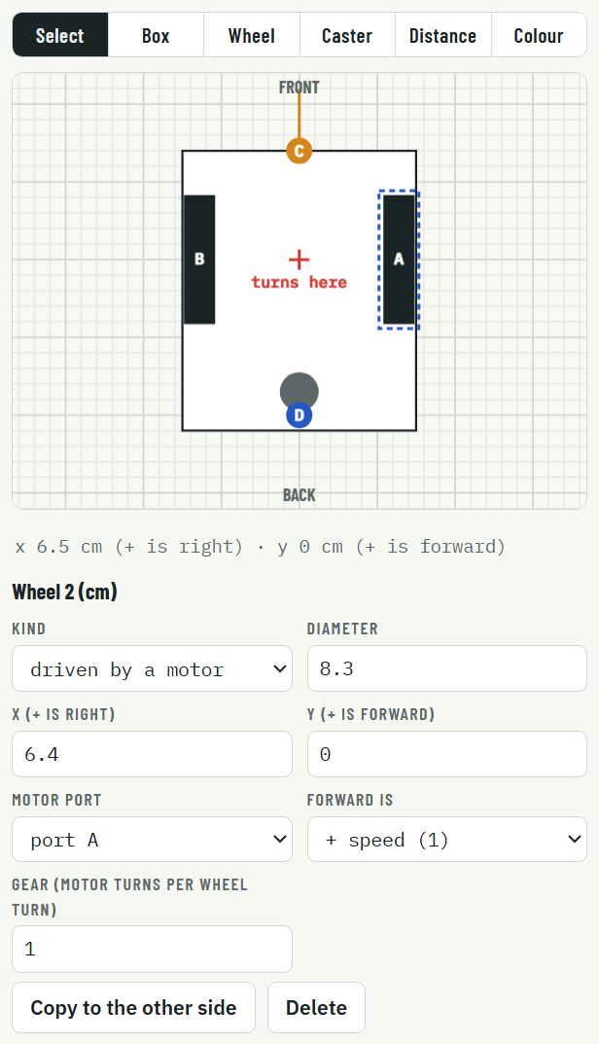
A wheel is selected: its settings appear under the editor.
Click a part to change it exactly:
- Wheels: Kind (driven by a motor; free, which rolls but cannot swivel; or caster), diameter, position, and for a driven wheel the motor port, which way is forward and the gear ratio. Copy to the other side adds the matching wheel on the other side.
- Sensors: port, position, and for the distance sensor the angle (0 = straight ahead).
- Boxes: the positions of their four edges.
The red + shows where the rover turns. If a change makes the rover unusable (for example, no driven wheel on one side), a message under the editor says what is missing, and the simulator keeps using the last working rover.
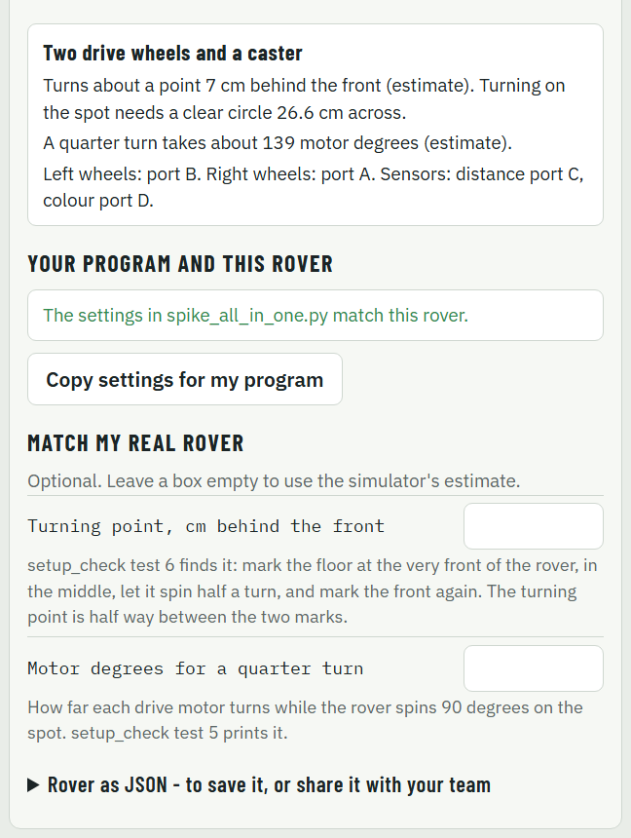
The bottom of the Rover tab.

The summary
It says where the rover turns, how big a clear circle it needs to turn on the spot, how many motor degrees a quarter turn takes, and which ports drive which side.

Your program and this rover
This compares the settings in your file with the rover you drew, and lists every setting that does not match. It also warns about things no setting can fix, such as two motors on one side, or wheels of different sizes on the same side.
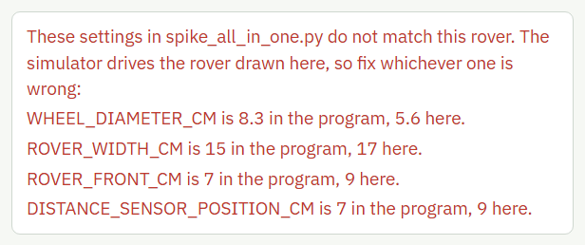
A four-wheel rover tested with the settings of a two-wheel rover.
Copy settings for my program copies the right settings for this rover. Paste them over the same lines in the SETTINGS part of your file.
Watch out: A rover that runs with the wrong settings drives the wrong distances, so it gets lost. In one test, a four-wheel rover exploring the course with the settings of a two-wheel rover was still searching after 15 minutes and had found only one of the two colours. With the right settings it found both in 7 minutes.

Match my real rover
For rovers with four or more wheels that cannot swivel, the simulator can only estimate how they turn. Enter two measurements from your real rover to make it turn the same way:
- Turning point, cm behind the front: from setup_check test 6.
- Motor degrees for a quarter turn: setup_check test 5 prints it.
Leave a box empty to use the estimate.

Saving and sharing your rover
The simulator remembers your rover in this browser. To save it, or share it with your team, open Rover as JSON, click Copy JSON and paste it into a text file. To load it, paste it back and click Apply JSON.

8. The Parameters tab
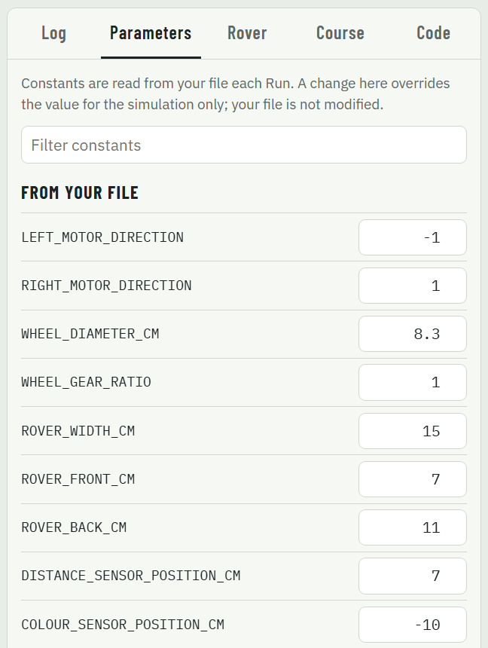
The first settings from your file.

From your file
Every number and True/False setting in the SETTINGS and FINE TUNING parts of your file. Change one here to try a different value in the simulator only: your file is not changed. Changed values are marked “changed” and stay changed until you click Clear all overrides. Type in the filter box to find a setting.
Watch out: When you find a value that works, write it into your file. Otherwise the real rover will not use it.
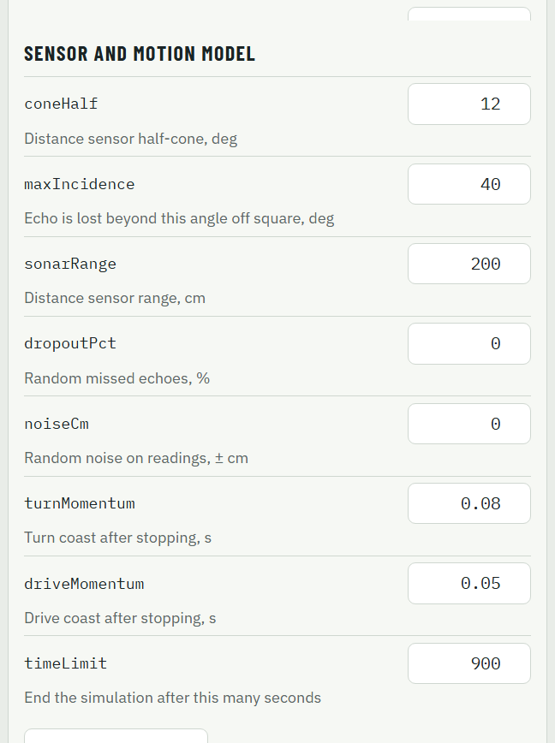
The sensor and motion model.

Sensor and motion model
How the pretend sensors and motors behave. Make them tougher to check your program copes with a less perfect world.
Parameter (default) | What it does
coneHalf (12) | Half the width of the distance sensor’s beam, in degrees.
maxIncidence (40) | A wall seen more than this many degrees off square bounces the sound away: no echo.
sonarRange (200) | The furthest the distance sensor can see, in cm.
dropoutPct (0) | The percentage of readings that randomly get no echo. Try 10.
noiseCm (0) | Random error added to each reading, in cm. Try 2.
turnMomentum (0.08), driveMomentum (0.05) | How far the rover coasts after the motors stop, in seconds of movement.
timeLimit (900) | The simulator stops a run after this many seconds.

9. The Course tab: drawing your course
The drawing tools.
Tool | How to use it
Look | Drag to move the view (no drawing).
Wall | Drag to draw a wall.
Green, Red | Drag to draw the green or red patch. There is one of each: drawing a new one replaces the old one.
Start | Click where the rover’s turning point starts. It always starts facing up the screen.
Erase | Click a wall or a patch to remove it.
Snap 5 cm | Keeps drawing on a 5 cm grid. Untick it for exact positions.

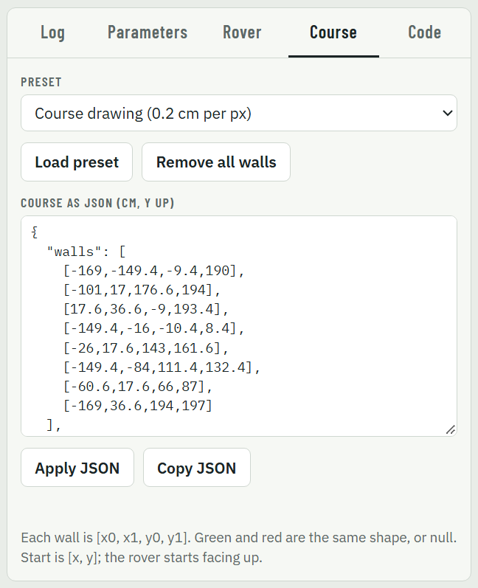
The Course tab.
The Course tab has three ready-made courses (Load preset) and Remove all walls. The course is also shown as JSON, in cm with y pointing up the screen: each wall is [x0, x1, y0, y1]. To build your competition course exactly, measure it, type the walls into the JSON and click Apply JSON. Copy JSON saves it to share.
Tip: You cannot edit the course while a run is going: press Reset first.

10. The Code tab
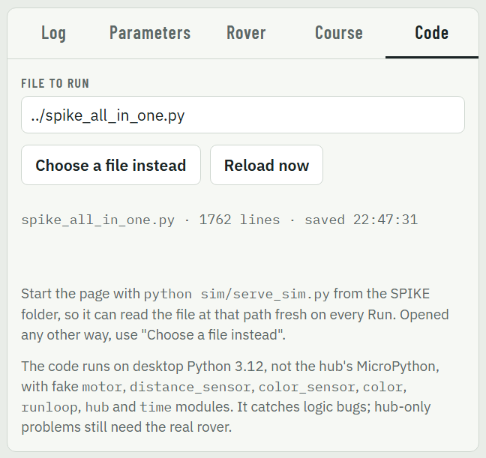
The Code tab.
- File to run: the program file the simulator reads, as a path from the simulator page. It only works when the page was started with python sim/serve_sim.py.
- Choose a file instead: pick your program file from the computer. Use this when you opened the page by double-clicking it.
- Reload now: read the file again without running it, for example to update the Parameters tab.
- The line below says which file was read, how many lines it has and when it was saved, so you can check it is the version you expect.

11. A good way to test
- Draw your rover on the Rover tab, and fix every setting in Your program and this rover until it says they match.
- Draw your competition course on the Course tab, as exactly as you can.
- Run setup_check (choose it in Program) to check the settings make sense.
- Run your program at Max speed to see the result, then at 5× or with Step to watch the decisions.
- When something goes wrong, click the Log lines just before it to see where the rover was and what it saw.
- Make it harder: in Parameters, set dropoutPct to 10 and noiseCm to 2, and move the start a few cm. A program that still works is much more likely to work on the floor.
- Test on the real rover. If it behaves differently, measure it (setup_check tests 5 and 6) and enter the numbers on the Rover tab.

12. Troubleshooting
What you see | What to do
Python failed at the top left | The simulator could not download Python. Connect to the internet and reload the page.
The Code tab says the page cannot read files by path, or could not read the file | Use Choose a file instead on the Code tab.
the file never calls runloop.run(...) | Exactly one runloop.run(...) line at the bottom of your file must have no # in front.
The red Settings do not match the rover badge | Open the Rover tab: it lists the settings that differ. Fix the rover drawing or your file.
A loop in your program reads sensors over and over but never waits | In the simulator, the rover only moves while your program waits. Put await runloop.sleep_ms(10) inside the loop.
TypeError: motor speeds must be whole numbers | Use int(...) around motor speeds. The hub stops with an error there too.
OSError ... no distance sensor on port ... | The port in your file has no sensor on the Rover tab. Fix the port in one of them.
TIME LIMIT | The run took longer than timeLimit. Raise it in Parameters, or make the program faster.
The run does not match the real rover | Compare settings (Rover tab), and enter your real rover’s measurements in Match my real rover.

